EXPERIMENT-5b
INPUT:
OUTPUT: 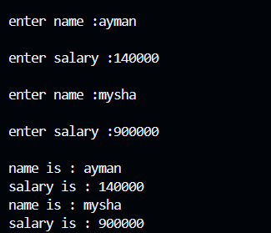
#include<iostream>
using namespace std;
class employee{
public:
string name;
int salary;
void putdata(){
cout<<"\nenter name :";
cin>>name;
cout<<"\nenter salary :";
cin>>salary;
}
void getdata(){
cout<<"\nname is : "<<name;
cout<<"\nsalary is : "<<salary;
}
};
int main (){
employee e[2];
for(int i=0;i<2;i++){
e[i].putdata();
}
for(int i=0;i<2;i++){
e[i].getdata();
}
return 0;
}

